

**INNOVATE. CREATE. SOLVE**

Bengaluru, Karnataka, India

AN INTERNSHIP REPORT

ON

“A website for Leaf Now”

#### Bachelor of Engineering

#### In

#### Information Science and Engineering

#### 

#### Submitted by: Kaushik P(4VV18IS041)

#### 

#### 

#### C:\Users\91809\OneDrive\Desktop\vvce logo.pngvvce logo

Vidyavardhaka College of Engineering

#### 2021

## ABOUT THE COMPANY

IC Solution (ICS) is a digital service provider that aims to provide software, designing and marketing solutions to individuals and businesses. At ICS, we believe that service and quality is the key to success

We provide all kinds of technological and designing solutions from Billing Software to Web Designs or any custom demand that you may have. Experience the service like none other!

Some of our services include:

Development - We develop responsive, functional and super-fast websites.

We keep User Experience in mind while creating websites. A website should load quickly and should be accessible even on a small view-port and slow internet connection.

Mobile Application - We offer a wide range of professional Android, iOS & Hybrid app development services for our global clients, from a start up to a large enterprise.

Design - We offer professional Graphic design, Brochure design & Logo design. We are experts in crafting visual content to convey the right message to the customers.

Consultancy - We are here to provide you with expert advice on your design and development requirement.

Videos - We create a polished professional video that impresses your audience.

**TABLE OF CONTENTS**

Table of contents i

Overview of the Project 1

About Leaf now 2

Features of leaf now 3

Tools Used 4

Implementation 5

Snapshots 7-13

Bibliography 14

## OVERVIEW OF THE PROJECT

## Project Name: A Website for Leaf Now

**Team Members: Bhavani Prasath N(1SB18EC011)**

**Kaushik P(4VV18IS041)**

**Priyanka K(1JT18IS047)**

**Bharathesh S Hukkeri(2JL19EC401)**

## This project is based on Web Development And its Applications. The main objective of this project is to learn the implementation of HTML, CSS and JavaScript. The basic webpage of this project is created using HTML and styling of the web-page is done using CSS.

This website is about LEAF NOW. Leaf now is all about saving the environment and to make a natural surrounding surpassing all new industries, global warming and deforestation. And this website helps a user to buy/sell and donate plants/seeds. Also user can donate money and that documentation will be converted to pdf as a motivation for other users to donate

.

## ABOUT LEAF NOW

.

Ever since industrialization started the care for plants has made it to their least priority list, Even though mankind requires plants to balance the food chain that he’s a part of, but the plant enthusiasts are everywhere, be it big metropolitan cities or rural areas, so they aim to bring in a platform that can connect these plant/nature enthusiasts and help them exchange/sell them plants or donate seeds/plants as part of the green initiative that they started 2 years back.

**Features of Leaf Now**

### The most important feature of LEAF NOW is connecting enthusiasts, which means that users should be able to create an account on the site and can start filling a form to submit their services, which will later be published by our team if it is genuine

### The second feature is encouraging users to sell/buy/donate plants/seeds, by letting them know the importance of the same

### The third important feature is the discussion page, set up a discussion page for the enthusiasts to start a discussion on topics that they like

### A pdf for every donation, a donation can be money (1rs for every plant) requires you to convert web content to pdf encouraging other users to do the same

# TOOLS USED

### Software Requirements

* Visual Studio Code 2019.
* Google Chrome or Microsoft Edge of latest version.
* Front End: HTML, CSS, JavaScript, BS(optional)
* PHP server-XAMPP, WAMP, etc.(optional yet recommended)
* MySQL Database – For managing data entered by the user.
* Windows XP/7/8/10 OS or Mac OS

### Hardware Requirements

* Pentium 200-MHz computer with a minimum of 64 MB of RAM (128 MB of RAM recommended).
* Monitor with a refresh rate of at least 40Hz for a smooth GUI experience (optional).

# 

# IMPLEMENTATION

# Source Code (index.HTML):

<!--index-->

<!DOCTYPE html>

<html lang="en" dir="ltr">

<head>

  <meta charset="utf=8">

  <title>Home</title>

  <link rel="stylesheet" href="style.css">

  <link href="https://cdn.jsdelivr.net/npm/bootstrap@5.1.1/dist/css/bootstrap.min.css" rel="stylesheet"

    integrity="sha384-F3w7mX95PdgyTmZZMECAngseQB83DfGTowi0iMjiWaeVhAn4FJkqJByhZMI3AhiU" crossorigin="anonymous">

  <script src="https://cdn.jsdelivr.net/npm/bootstrap@5.1.1/dist/js/bootstrap.bundle.min.js"

    integrity="sha384-/bQdsTh/da6pkI1MST/rWKFNjaCP5gBSY4sEBT38Q/9RBh9AH40zEOg7Hlq2THRZ"

    crossorigin="anonymous"></script>

  <script src="https://kit.fontawesome.com/7450de4497.js" crossorigin="anonymous"></script>

  <meta name="veiwport" content="width=device-width, intial-scale=1.0">

</head>

<body>

  <nav>

    <div><img src="Bionic.jpg" width="100" height="100"></div>

    <div class="logo">Leaf now</div>

    <ul>

      <li><a class="active" href="#">Home</a></li>

      <li><a href="contact.html">Contact Us</a></li>

      <li><a href="about.html">About Us</a></li>

    </ul>

  </nav>

  <h1 class="heading1">

    OVERVIEW and DETAILS

  </h1>

  <p class="desc">

    Ever since industrialization started the care for plants has made it to our least priority

    list, Even though mankind requires plants to balance the food chain that he’s a part of,

    but the plant enthusiasts are everywhere, be it big metropolitan cities or rural areas, so

    we aim to bring in a platform that can connect these plant/nature enthusiasts and help

    them exchange/sell them plants or donate seeds/plants as part of the green initiative

    that we started 2 years back.

  </p>

  <h1 class="heading2">

    Leaf now are well known for

  </h1>

  <p class="desc">

    The most important feature of LEAF NOW is connecting enthusiasts, which means that

      users are able to create an account on the site and can start filling a form to

      submit their services

      The second feature is encouraging users to sell/buy/donate plants/seeds, by letting

      them know the importance of the same

      A pdf for every donation, a donation can be money(1rs for every plant).</p>

      <br>

  <footer class="bg-dark text-center text-white">

    <!-- Grid container -->

    <div class="container p-4">

      <!-- Section: Social media -->

      <section class="mb-4">

        <!-- Facebook -->

        <a class="btn btn-outline-light btn-floating m-1" href="#!" role="button"><i class="fab fa-facebook"></i></a>

        <!-- Twitter -->

        <a class="btn btn-outline-light btn-floating m-1" href="#!" role="button"><i class="fab fa-twitter"></i></a>

        <!-- Google -->

        <a class="btn btn-outline-light btn-floating m-1" href="#!" role="button"><i class="fab fa-google"></i></a>

        <!-- Instagram -->

        <a class="btn btn-outline-light btn-floating m-1" href="#!" role="button"><i class="fab fa-instagram"></i></a>

        <!-- Linkedin -->

        <a class="btn btn-outline-light btn-floating m-1" href="#!" role="button"><i class="fab fa-linkedin-in"></i></a>

        <!-- Github -->

        <a class="btn btn-outline-light btn-floating m-1" href="#!" role="button"><i class="fab fa-github"></i></a>

      </section>

      <!-- Section: Social media -->

      <!-- Section: Links -->

      <section class="">

        <!--Grid row-->

        <div class="row">

          <!--Grid column-->

          <div class="col-lg-3 col-md-6 mb-4 mb-md-0">

            <h5 class="text-uppercase">Email</h5>

            <ul class="list-unstyled mb-0">

              <li>

                <a href="#!" class="text-white">leafnow@gmail.com</a>

              </li>

            </ul>

          </div>

          <!--Grid column-->

          <!--Grid column-->

          <div class="col-lg-3 col-md-6 mb-4 mb-md-0">

            <h5 class="text-uppercase">contact Number</h5>

            <ul class="list-unstyled mb-0">

              <li>

                <a href="#!" class="text-white">8415730011</a>

              </li>

              <li>

                <a href="#!" class="text-white">9515731122</a>

              </li>

            </ul>

          </div>

          <!--Grid column-->

          <!--Grid column-->

          <div class="col-lg-3 col-md-6 mb-4 mb-md-0">

            <h5 class="text-uppercase">Address</h5>

            <ul class="list-unstyled mb-0">

              <li>

                <h6>Leaf now,<br>

                  No.420, 1st Main, 3rd Cross, Dollars colony, Bangalore - 560094

                </h6>

              </li>

            </ul>

          </div>

          <!--Grid column-->

  </footer>

</body>

</html>

# Source Code (contact.html)

<!--contact-->

<!DOCTYPE html>

<html lang="en">

<head>

  <meta charset="UTF-8">

  <meta http-equiv="X-UA-Compatible" content="IE=edge">

  <meta name="viewport" content="width=device-width, initial-scale=1.0">

  <link rel="stylesheet" href="style.css">

  <link href="https://cdn.jsdelivr.net/npm/bootstrap@5.1.1/dist/css/bootstrap.min.css" rel="stylesheet"

    integrity="sha384-F3w7mX95PdgyTmZZMECAngseQB83DfGTowi0iMjiWaeVhAn4FJkqJByhZMI3AhiU" crossorigin="anonymous">

  <script src="https://cdn.jsdelivr.net/npm/bootstrap@5.1.1/dist/js/bootstrap.bundle.min.js"

    integrity="sha384-/bQdsTh/da6pkI1MST/rWKFNjaCP5gBSY4sEBT38Q/9RBh9AH40zEOg7Hlq2THRZ"

    crossorigin="anonymous"></script>

  <script src="https://kit.fontawesome.com/7450de4497.js" crossorigin="anonymous"></script>

  <title>Contact</title>

</head>

<body>

  <nav>

    <div><img src="Bionic.jpg" width="100" height="100"></div>

    <div class="logo">Leaf now!</div>

    <ul>

      <li><a href="index.html">Home</a></li>

      <li><a class="active" href="contact.html">Contact Us</a></li>

      <li><a href="about.html">About Us</a></li>

    </ul>

  </nav>

  <div class="formd">

    <button class="formbtn" onclick="window.location.href='formdetails.php';">Form Filled Details(View)</button>

  </div>

  <h2 class="heading4" style="font-size: 4em;">To get in touch with us ...</h2>

  <!-- form-->

  <div class="container">

    <form name="myForm" onsubmit="return validate()" action="success.php" method="POST">

      <label for="name">Name</label>

      <input type="text" id="name" name="name" placeholder="Your name..">

      <label for="lname">Email</label>

      <input type="text" id="email" name="email" placeholder="Your Email..">

      <label for="numbers">phone number</label>

      <input type="text" id="number" name="number" placeholder="Your phone number ..">

      <label for="Address">Address</label>

      <textarea id="Address" name="Address" placeholder="Your Address" style="height:200px"></textarea>

      <label for="Assistance">Type of Assistance you need </label>

      <textarea id="Assistance" name="Assistance" placeholder="i,e do you want to buy/sell/donate plants" style="height:200px"></textarea>

      <input type="submit" value="Submit">

    </form>

  </div>

  <script>

    function validate() {

      var name = document.forms["myForm"]["name"].value;

      var email = document.forms["myForm"]["email"].value;

      var number = document.forms["myForm"]["number"].value;

      var Address = document.forms["myForm"]["Address"].value;

var  Assistance = document.forms["myForm"][ "Assistance"].value

      if (name == "" || email == "" || number == "" || Address == "" ||Assistance == "") {

        alert("All the fields must be filled out");

        return false;

      }

      else

        return true;

    }

  </script>

  <footer class="bg-dark text-center text-white">

    <!-- Grid container -->

    <div class="container p-4">

      <!-- Section: Social media -->

      <section class="mb-4">

        <!-- Facebook -->

        <a class="btn btn-outline-light btn-floating m-1" href="#!" role="button"><i class="fab fa-facebook-f"></i></a>

        <!-- Twitter -->

        <a class="btn btn-outline-light btn-floating m-1" href="#!" role="button"><i class="fab fa-twitter"></i></a>

        <!-- Google -->

        <a class="btn btn-outline-light btn-floating m-1" href="#!" role="button"><i class="fab fa-google"></i></a>

        <!-- Instagram -->

        <a class="btn btn-outline-light btn-floating m-1" href="#!" role="button"><i class="fab fa-instagram"></i></a>

        <!-- Linkedin -->

        <a class="btn btn-outline-light btn-floating m-1" href="#!" role="button"><i class="fab fa-linkedin-in"></i></a>

        <!-- Github -->

        <a class="btn btn-outline-light btn-floating m-1" href="#!" role="button"><i class="fab fa-github"></i></a>

      </section>

      <!-- Section: Social media -->

      <!-- Section: Links -->

      <section class="">

        <!--Grid row-->

        <div class="row">

          <!--Grid column-->

          <div class="col-lg-3 col-md-6 mb-4 mb-md-0">

            <h5 class="text-uppercase">Email</h5>

            <ul class="list-unstyled mb-0">

              <li>

                <a href="#!" class="text-white">leafnow@gmail.com</a>

              </li>

            </ul>

          </div>

          <!--Grid column-->

          <!--Grid column-->

          <div class="col-lg-3 col-md-6 mb-4 mb-md-0">

            <h5 class="text-uppercase">contact Number</h5>

            <ul class="list-unstyled mb-0">

              <li>

                <a href="#!" class="text-white">8415730011</a>

              </li>

              <li>

                <a href="#!" class="text-white">9515731122</a>

              </li>

            </ul>

          </div>

          <!--Grid column-->

          <!--Grid column-->

          <div class="col-lg-3 col-md-6 mb-4 mb-md-0">

            <h5 class="text-uppercase">Address</h5>

            <ul class="list-unstyled mb-0">

              <li>

                <h6>Leaf now,<br>

                  No 420, 1st Main, 4th Cross, Dollars colony, Bangalore - 560294

                </h6>

              </li>

            </ul>

          </div>

          <!--Grid column-->

  </footer>

</body>

</html>

**SOURCE CODE (about.html)**

<!--about-->

<!DOCTYPE html>

<html lang="en">

<head>

  <meta charset="UTF-8">

  <meta http-equiv="X-UA-Compatible" content="IE=edge">

  <meta name="viewport" content="width=device-width, initial-scale=1.0">

  <link rel="stylesheet" href="style.css">

  <link href="https://cdn.jsdelivr.net/npm/bootstrap@5.1.1/dist/css/bootstrap.min.css" rel="stylesheet"

    integrity="sha384-F3w7mX95PdgyTmZZMECAngseQB83DfGTowi0iMjiWaeVhAn4FJkqJByhZMI3AhiU" crossorigin="anonymous">

  <script src="https://cdn.jsdelivr.net/npm/bootstrap@5.1.1/dist/js/bootstrap.bundle.min.js"

    integrity="sha384-/bQdsTh/da6pkI1MST/rWKFNjaCP5gBSY4sEBT38Q/9RBh9AH40zEOg7Hlq2THRZ"

    crossorigin="anonymous"></script>

  <script src="https://kit.fontawesome.com/7450de4497.js" crossorigin="anonymous"></script>

  <title>About</title>

</head>

<body>

  <nav>

    <div><img src="Bionic.jpg" width="100" height="100"></div>

    <div class="logo">Leaf now!</div>

    <ul>

      <li><a href="index.html">Home</a></li>

      <li><a href="contact.html">Contact Us</a></li>

      <li><a class="active" href="about.html">About Us</a></li>

    </ul>

  </nav>

  <h1 class="heading3">Things about us</h1>

  <p class="about1">

    We aim to bring in a platform that can connect these plant/nature enthusiasts and help

    them exchange/sell them plants or donate seeds/plants as part of the green initiative

    that we started 2 years back. We cater to all kinds of gardening needs ranging from plants, pots, tools, to curated

    plant-scaping solutions. Our

    ever-growing platform integrates nurseries and customers across India.

    If you’re new to being a plant parent, we’re here to make it easier. Our garden experts can provide you with

    guidance

    for detailed care every step of the way.

    We believe that every space can be made more beautiful with plants! Come, join us in our vision to make all spaces

    green

    and healthy!

  </p>

  <h1 class="heading3">How we work</h1>

  <ul class="about1" id="list">

    <li>

      Plants, simplified: Order plants ready to be placed in your home, office or garden. Just Unpack, Relax and Enjoy

      your green buddies

    </li>

    <li>

      Secure Shipping: Our unique packaging will hold the plants in place and let the plant breathe so that it reaches

      you

      fresh without any mess.

    </li>

    <li>

      Detailed Guidance: Get detailed plant care instructions from the website as well as real-time guidance from our

      Garden

      Experts on Whatsapp.

    </li>

  </ul>

  <footer class="bg-dark text-center text-white">

    <!-- Grid container -->

    <div class="container p-4">

      <!-- Section: Social media -->

      <section class="mb-4">

        <!-- Facebook -->

        <a class="btn btn-outline-light btn-floating m-1" href="#!" role="button"><i class="fab fa-facebook-f"></i></a>

        <!-- Twitter -->

        <a class="btn btn-outline-light btn-floating m-1" href="#!" role="button"><i class="fab fa-twitter"></i></a>

        <!-- Google -->

        <a class="btn btn-outline-light btn-floating m-1" href="#!" role="button"><i class="fab fa-google"></i></a>

        <!-- Instagram -->

        <a class="btn btn-outline-light btn-floating m-1" href="#!" role="button"><i class="fab fa-instagram"></i></a>

        <!-- Linkedin -->

        <a class="btn btn-outline-light btn-floating m-1" href="#!" role="button"><i class="fab fa-linkedin-in"></i></a>

        <!-- Github -->

        <a class="btn btn-outline-light btn-floating m-1" href="#!" role="button"><i class="fab fa-github"></i></a>

      </section>

      <!-- Section: Social media -->

      <!-- Section: Links -->

      <section class="">

        <!--Grid row-->

        <div class="row">

          <!--Grid column-->

          <div class="col-lg-3 col-md-6 mb-4 mb-md-0">

            <h5 class="text-uppercase">Email</h5>

            <ul class="list-unstyled mb-0">

              <li>

                <a href="#!" class="text-white">leafnow@gmail.com</a>

              </li>

            </ul>

          </div>

          <!--Grid column-->

          <!--Grid column-->

          <div class="col-lg-3 col-md-6 mb-4 mb-md-0">

            <h5 class="text-uppercase">contact Number</h5>

            <ul class="list-unstyled mb-0">

              <li>

                <a href="#!" class="text-white">8415730011</a>

              </li>

              <li>

                <a href="#!" class="text-white">9515731122</a>

              </li>

            </ul>

          </div>

          <!--Grid column-->

          <!--Grid column-->

          <div class="col-lg-3 col-md-6 mb-4 mb-md-0">

            <h5 class="text-uppercase">Address</h5>

            <ul class="list-unstyled mb-0">

              <li>

                <h6>Leaf now,<br>

                  No 420, 1st Main, 4th Cross, Dollars colony, Bangalore - 560294

                </h6>

              </li>

            </ul>

          </div>

          <!--Grid column-->

  </footer>

</body>

</html>

**Source code (style.css)**

@import url("https://fonts.googleapis.com/css?family=Poppins:400,500,600,700&display=swap");

@import url("https://fonts.googleapis.com/css2?family=Balsamiq+Sans&display=swap");

* {

  margin: 0;

  padding: 0;

  box-sizing: border-box;

  font-family: "Poppins", sans-serif;

}

body {

  background-image: url("https://images.pexels.com/photos/6913773/pexels-photo-6913773.jpeg?auto=compress&cs=tinysrgb&dpr=2&h=750&w=1260");

  background-repeat: no-repeat;

  background-attachment: fixed;

  background-size: cover;

}

.heading1 {

  /* color: #fff; */

  /* padding-left: 1076px;

  padding-top: 30px; */

 font-family:Georgia, 'Times New Roman', Times, serif ;

  padding-top: 35px;

  text-align: center;

}

.desc {

   color: rgb(0, 0, 0);

  /* padding-left: 900px;

  padding-right: 100px;

  */

  padding-top: 30px;

  text-align: center;

  font-size: x-large;

  font-family:Georgia, 'Times New Roman', Times, serif;

}

.heading2 {

  font-family: Georgia, 'Times New Roman', Times, serif;

  text-align: center;

  /* padding-left: 963px;

  */

  padding-top: 100px;

}

.heading3 {

  font-family: Georgia, 'Times New Roman', Times, serif;

  text-align: center;

  font-size: 50px;

}

.heading4 {

  font-family: Georgia, 'Times New Roman', Times, serif;

  text-align: center;

  padding-top: 30px;

  font-size: 40px;

  font-weight: bold;

}

.contact {

  font-size: 300%;

  padding-left: 550px;

  padding-top: 30px;

}

.linelist {

  /* padding-left: 971px; */

  padding-top: 73px;

  padding-bottom: 153px;

  text-align: center;

  font-size: larger;

  font-family: Georgia, 'Times New Roman', Times, serif;

}

nav {

  height: 120px;

  background: rgb(52 179 44);

  display: flex;

  align-items: center;

  justify-content: space-between;

  padding: 0px 50px 0px 100px;

}

nav .logo {

  font-size: 40px;

  color: #fff;

  font-weight: 600;

}

nav ul {

  display: flex;

  list-style: none;

}

nav ul li {

  margin: 0 35px;

}

nav ul li a {

  color: #fff;

  font-family: Georgia, 'Times New Roman', Times, serif;

  text-decoration: none;

  font-size: 18px;

  font-weight: 500;

  letter-spacing: 1px;

  padding: 8px 10px;

  border-radius: 5px;

  transition: all 0.3s ease;

}

nav img {

  float: left;

}

nav ul li a:hover,

nav ul li a.active {

  color: #1b1b1b;

  background: #fff;

}

.row {

  padding-left: 260px;

}

.about1 {

  /* padding-left: 900px;

  padding-top: 30px; */

  /* padding-right: 100px; */

  padding: 20px;

  margin: 53px;

  text-align: justify;

  font-size: x-large;

  font-family: Georgia, 'Times New Roman', Times, serif;

}

#list {

  text-align: left;

}

.about2 {

  padding-left: 900px;

  padding-top: 30px;

  padding-right: 100px;

  padding-bottom: 30px;

  text-align: center;

  font-size: x-large;

  font-family:Georgia, 'Times New Roman', Times, serif;

}

input[type="text"],

select,

textarea {

  width: 100%; /* Full width */

  padding: 12px; /* Some padding */

  border: 1px solid #ccc; /* Gray border */

  border-radius: 4px; /* Rounded borders */

  /* Make sure that padding and width stays in place */

  margin-top: 6px; /* Add a top margin */

  margin-bottom: 16px; /* Bottom margin */

  resize: vertical; /* Allow the user to vertically resize the textarea (not horizontally) */

}

/* Style the submit button with a specific background color etc */

input[type="submit"] {

  background-color: #07afb4;

  color: white;

  padding: 12px 20px;

  border: none;

  border-radius: 4px;

  cursor: pointer;

}

/* When moving the mouse over the submit button, add a darker green color */

input[type="submit"]:hover {

  background-color:lightgreen;

}

/* Add a background color and some padding around the form */

.container {

  border-radius: 5px;

  padding: 20px;

}

.success {

  text-align: center;

  color: rgb(0, 17, 255);

  font-weight: bold;

  margin-top: 70px;

}

.homebtn {

  border: none;

  color: rgb(255, 255, 255);

  background-color: rgb(31, 34, 36);

  padding: 15px 32px;

  text-align: center;

  text-decoration: none;

  display: inline-block;

  font-size: 16px;

  margin: 4px 2px;

  cursor: pointer;

  border-radius: 20px;

  margin-top: 20px;

  transition: all 0.3s ease;

}

.homebtn:hover {

  background-color: rgb(0, 195, 255);

}

.successlogo {

  text-align: center;

  font-size: 40px;

  padding-top: 20px;

  color: rgb(29, 6, 233);

  font-weight: bold;

}

.formbtn {

  border: none;

  color: rgb(255, 255, 255);

  background-color: rgb(63, 129, 184);

  padding: 15px 32px;

  text-align: center;

  text-decoration: none;

  display: inline-block;

  font-size: 16px;

  margin: 4px 2px;

  cursor: pointer;

  border-radius: 20px;

  margin-top: 20px;

}

.formbtn:hover {

  background-color: rgb(16, 15, 92);

  transition: all 0.3s ease;

}

.formd {

  text-align: center;

}

table {

  width: 600px;

  line-height: 40px;

  align-items: center;

  border: 2px solid black;

}

.formtable th,

tr {

  background-color: #fff;

  border-bottom: 2px solid black;

  border-collapse: collapse;

  min-width: 200px;

}

.tablediv {

  text-align: center;

  padding-left: 40px;

  padding-right: 100px;

  padding-top: 50px;

}

table,

th,

td {

  width: 600px;

  line-height: 40px;

  align-items: center;

  border: 2px solid black;

}

.foot {

  background-color: ;

  padding-top: 30px;

}

.logo

{

  font-family:Georgia, 'Times New Roman', Times, serif;

  font-style:italic;

}

.about1{

  font-family: Georgia, 'Times New Roman', Times, serif;

}

# Snapshots

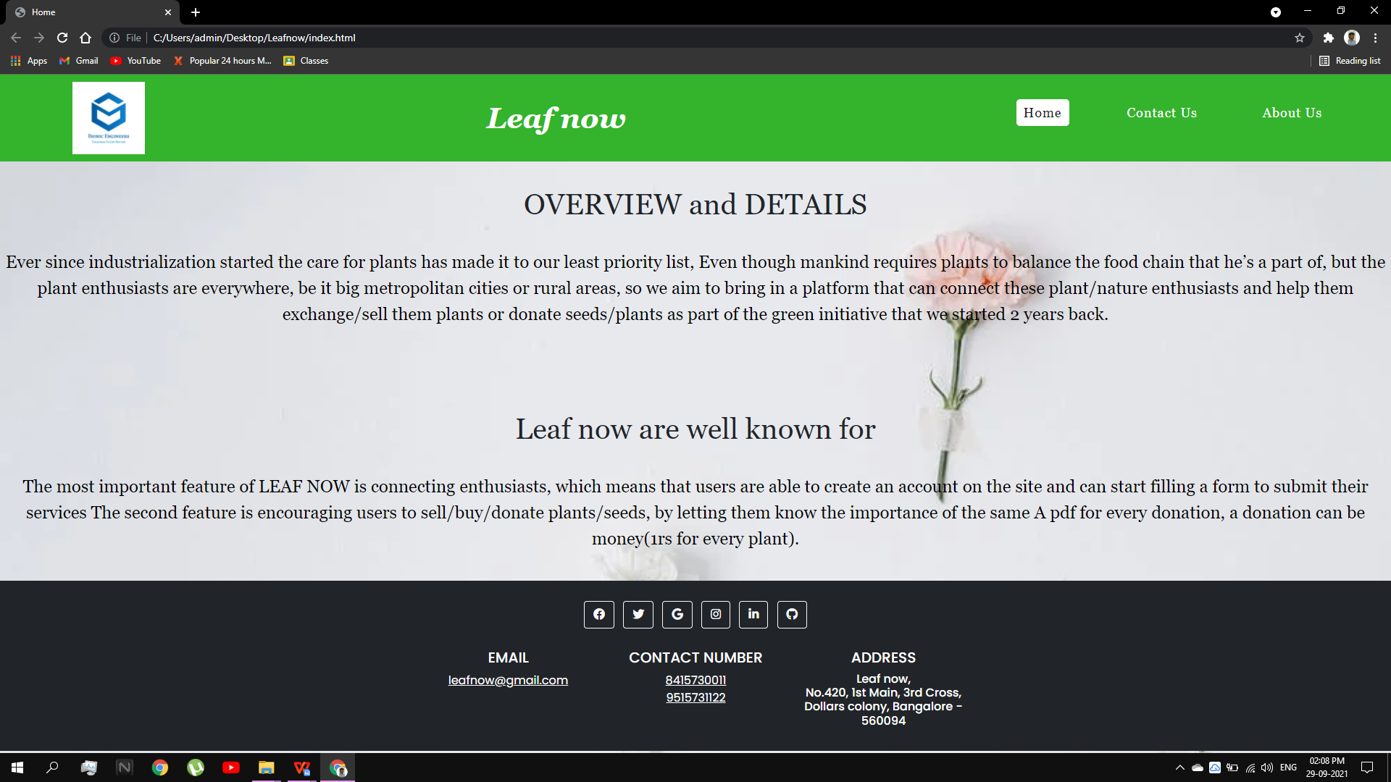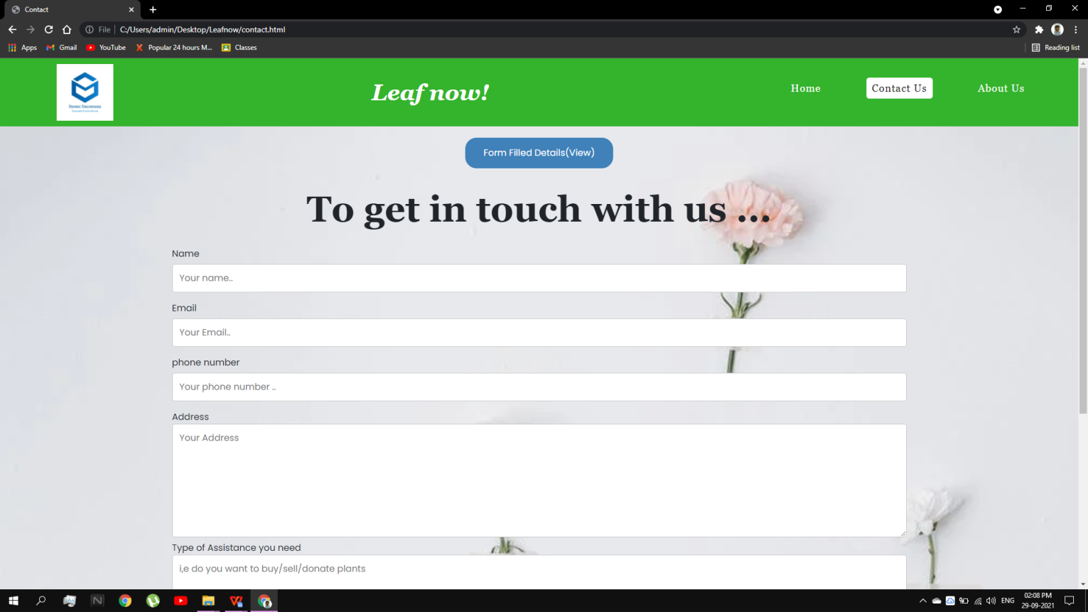

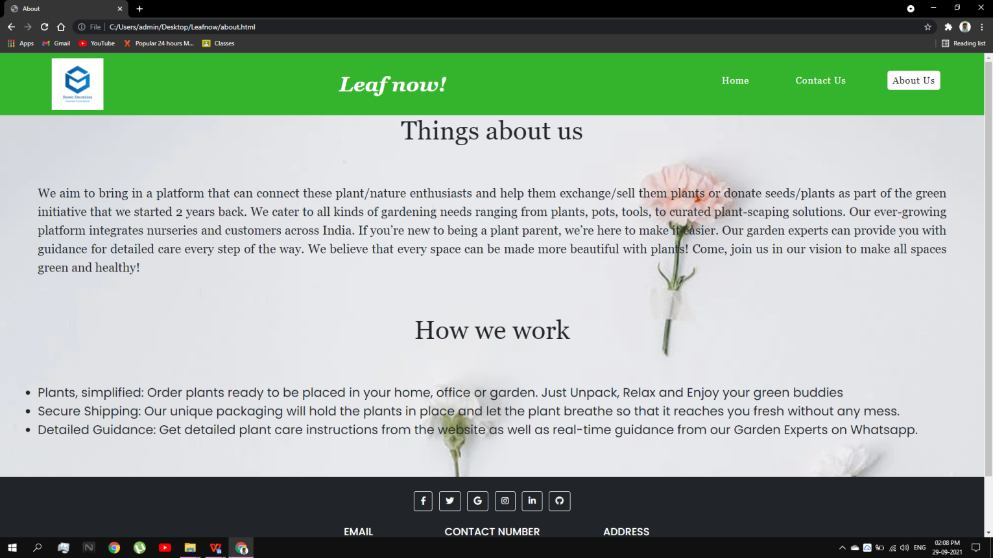

**Bibliography**

* **<https://www.javatpoint.com/dbms-tutorial>**
* **<https://www.phpmyadmin.net/>**
* **<https://www.w3schools.com/howto/howto_make_a_website.asp>**
* **<https://www.w3schools.com/js/DEFAULT.asp>**

## About my TEAM

Our team members are:

BHAVANI PRASATH N studying at SRI SAI RAM COLLEGE OF ENGINEERING, of branch Electronics Communication and engineering has actively participated in this project by designing the home page using html and css and overview about project in project report.

KAUSHIK P studying in VIDYAVARDHAKA COLLEGE OF ENGINEERING, OF Information Science and Engineering, actively participated in designing and creating page1 and page2 using css and html and implementation, results in project report.

PRIYANKA K studying in JYOTHY INSTITUTE OF TECHNOLOGY, Of Information Science and Engineering, Has designed and created page3 using html, css, about us page in the project report.

BHARATESH S HUKKERI studying in JAIN COLLEGE OF ENGINEERING BELAGAVI.

Have contributed by collecting the information for the project, and project report.